DPCT1009 analysis

Warning message:

SYCL uses exceptions to report errors and does not use error codes. The original code was commented out and a warning string was inserted. You may need to rewrite this code.

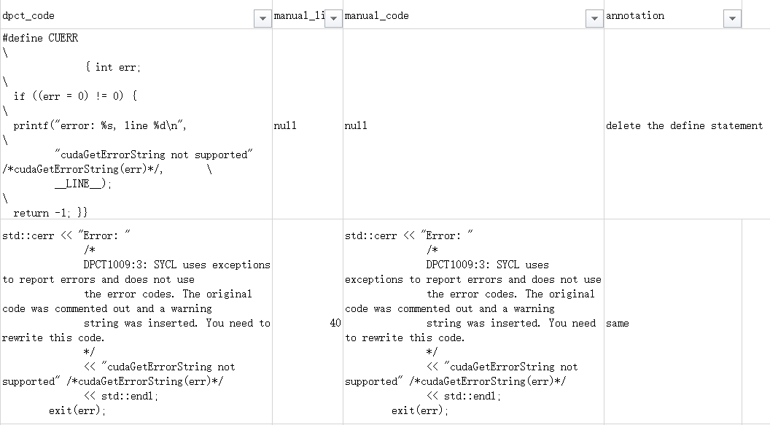

Only 2 projects/files have this type of warning, and it appear 2 times. (Data hungry)

File path:

/clenergy/dpcpp/clenergy.dp.cpp

/reduction/dpcpp/reduction.dp.cpp

One deletes the define statement

Another accepted the DPCT proposal